# CS 340 README

*.*

## About the Project/Project Title

This project was designed to allow a user to easily use C-R-U-D (Create, Read, Update, Delete) actions within a MongoDB server through the Pymongo driver. Currently it automatically connects to the “animals” collection in the “aac” database upon initialization.

## Motivation

Some people find it hard to utilize the functions of MongoDB so I wanted to simplify things a bit by creating easy to use functions to interact with the database. This module will also make it easy to connect the database to a user interface so we can simplify things even more.

## Getting Started

Once you have downloaded the CRUD.py file you should set it in your working directory for easy import or you can set a dependency path to the file (harder).

## Installation

You will need the following tools to utilize this module:

Python which can be downloaded at [Download Python | Python.org](https://www.python.org/downloads/)

MongoDB which can be found at <https://www.mongodb.com>

Pymongo which can be downloaded using pip in the cmd line by typing the following:

**python -m pip install pymongo**

You can also reference [PyMongo — MongoDB Drivers](https://www.mongodb.com/docs/drivers/pymongo/) for more help with installation

## Usage

The following examples will explain the constructor and functions of my program.

### Code Examples

First you should import the module using **from CRUD import AnimalShelter**

*Constructor***:**

**animals = AnimalShelter()**

This will initialize a connection to the MongoDB database and store it in the variable “animals”. You can rename 'animals” to whatever you would like. You can now access the CRUD functions through that variable.

*create(data):*

**NewRecord = animals.create({‘animal_id’: ‘Test001’})**

This will create a new record in the database with the data set {‘animal_id’: ‘Test001’}

You can add as many key: value pairs as you would like to the data parameter.

You don’t necessarily need to create a new variable but we did this to show if you print it then it will return True indicating that the record was successfully created.

*read(query):*

***Animals.read({*‘animal_id’: ‘Test001’})**

This will return a list of items that match the query. If you input an empty set {} then it will return all the records in the collection. The example above will return our animal that we created previously.

*update(query, data):*

***UpdatedRecord = animals.update({‘animal_id’: ‘Test001’}, {‘name’: ‘Testy’})***

This will update the previous example to add a new key: value pair giving our animal a “name” of “Testy”. Again, you don’t need to create a new variable but printing it will show the number of records updated. It’s recommended to use the ID number as the query so you don’t update the wrong animal.

delete(query):

**DeletedRecord = animals.delete({‘animal_id’: ‘Test001’})**

This will delete our created animal. You don’t need to create a new variable but printing it will show the number of records deleted. It’s recommended to use the ID number as the query so you don’t delete the wrong animal.

### Tests

The screenshot below shows the outcomes of the code examples provided above.

### Screenshots

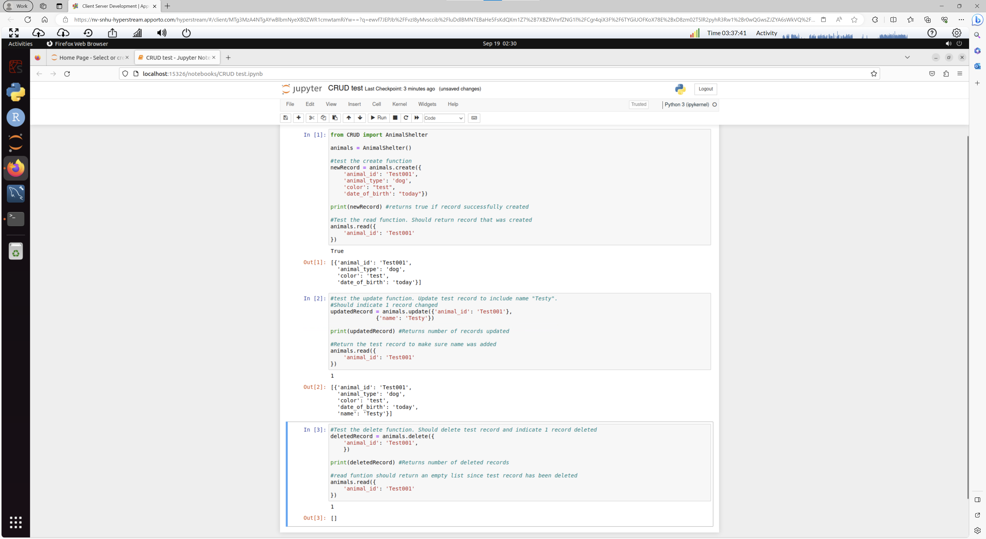

## Roadmap/Features (Optional)

This module currently only allows you to connect to the “animals” collection in the “aac” database. In the future we will add the ability to specify your own MongoDB server.

## Contact

Name: Afahri Kerr

E-mail: [Afahri.Kerr@SNHU.edu](mailto:Afahri.Kerr@SNHU.edu)

**How to re-create project**

For this project we first had to create a database and we did that by using the mongoimport tool from the terminal to import our csv file.

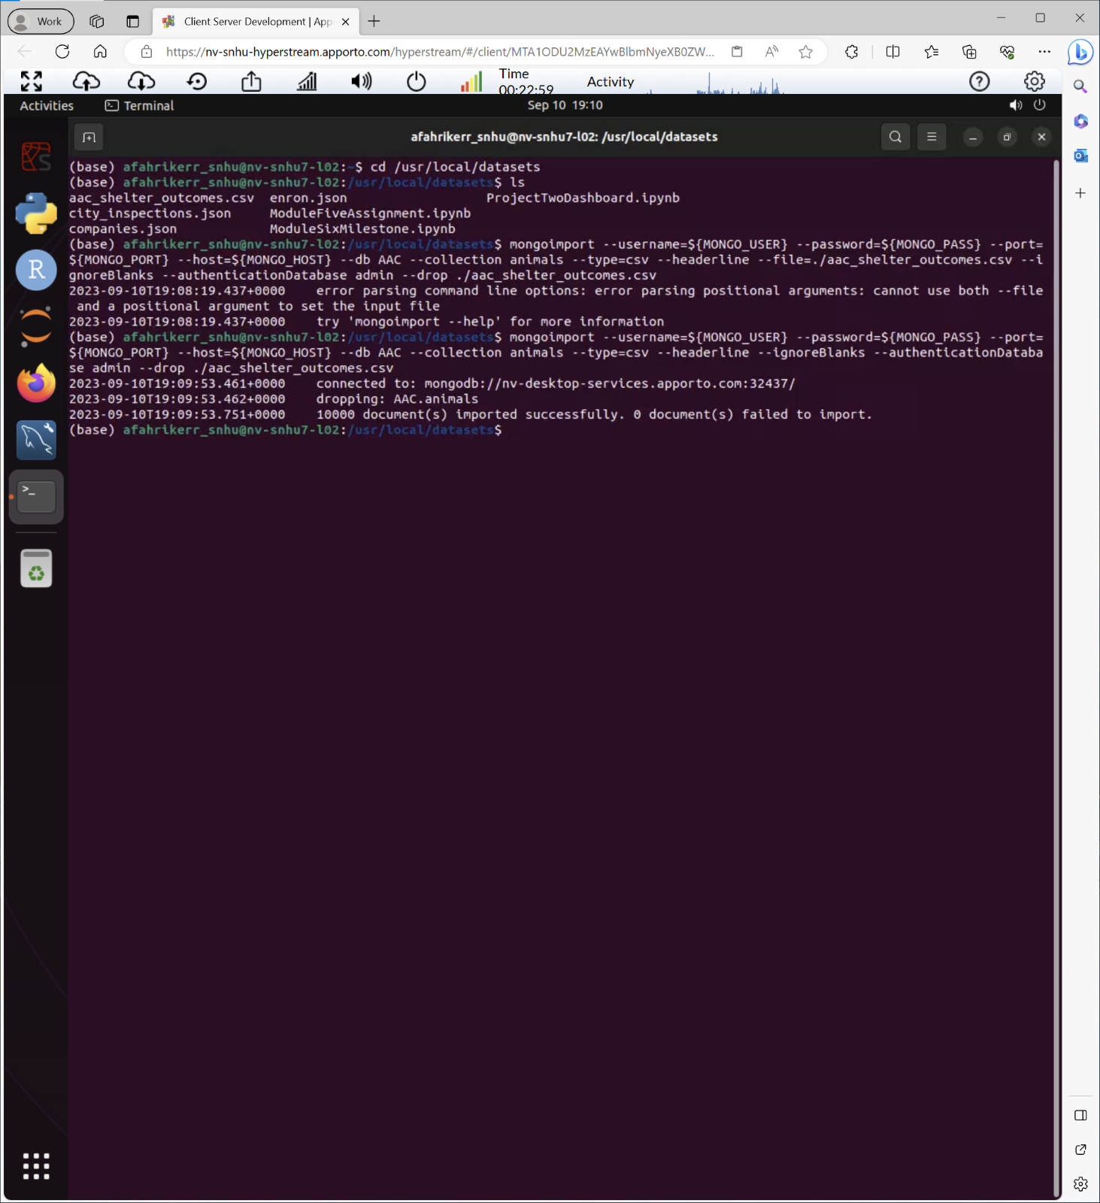

Next, we created a user account from the terminal to access the database and gave them read-write permissions. We accomplished this by using the createUser() method.

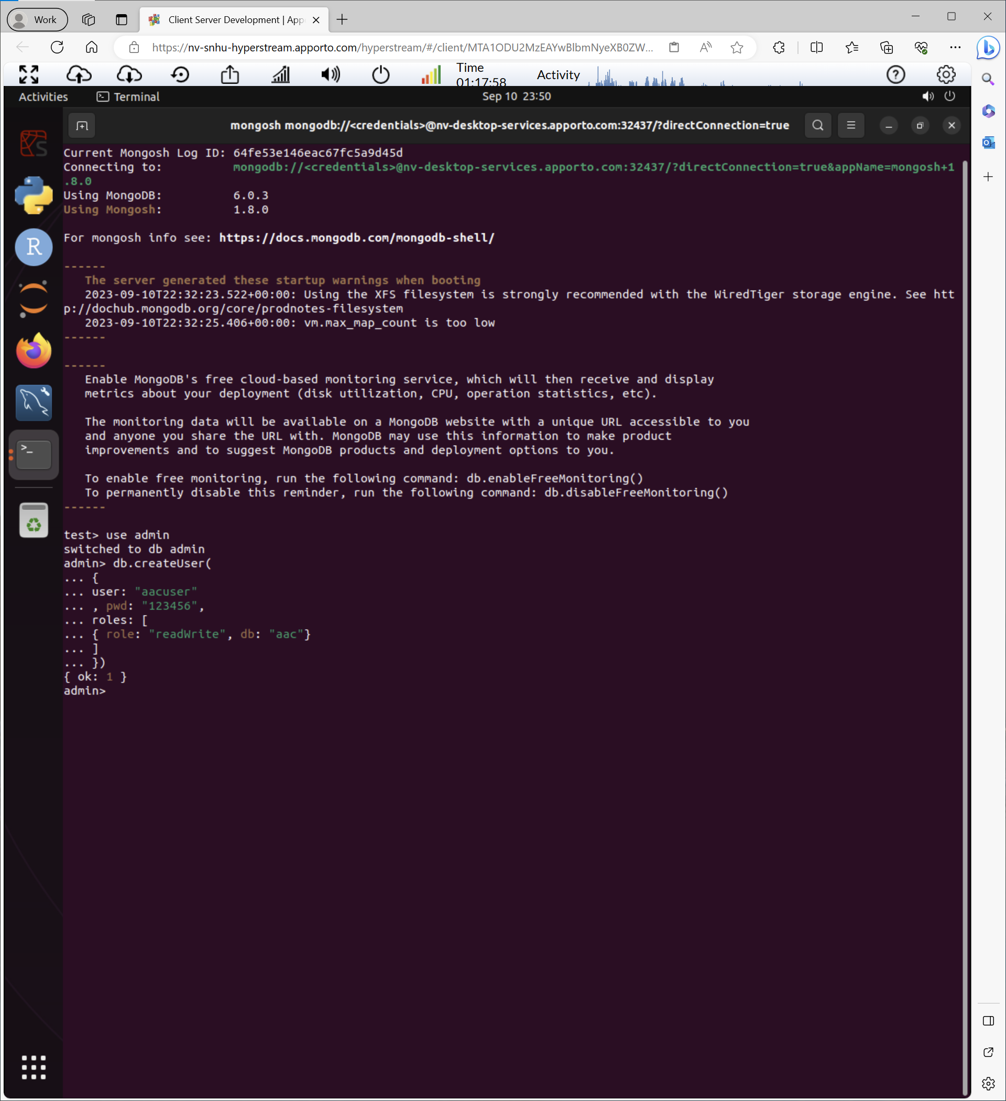

You can see that our user was successfully by using the db.runCommand(ConnectionStatus:1}) method.

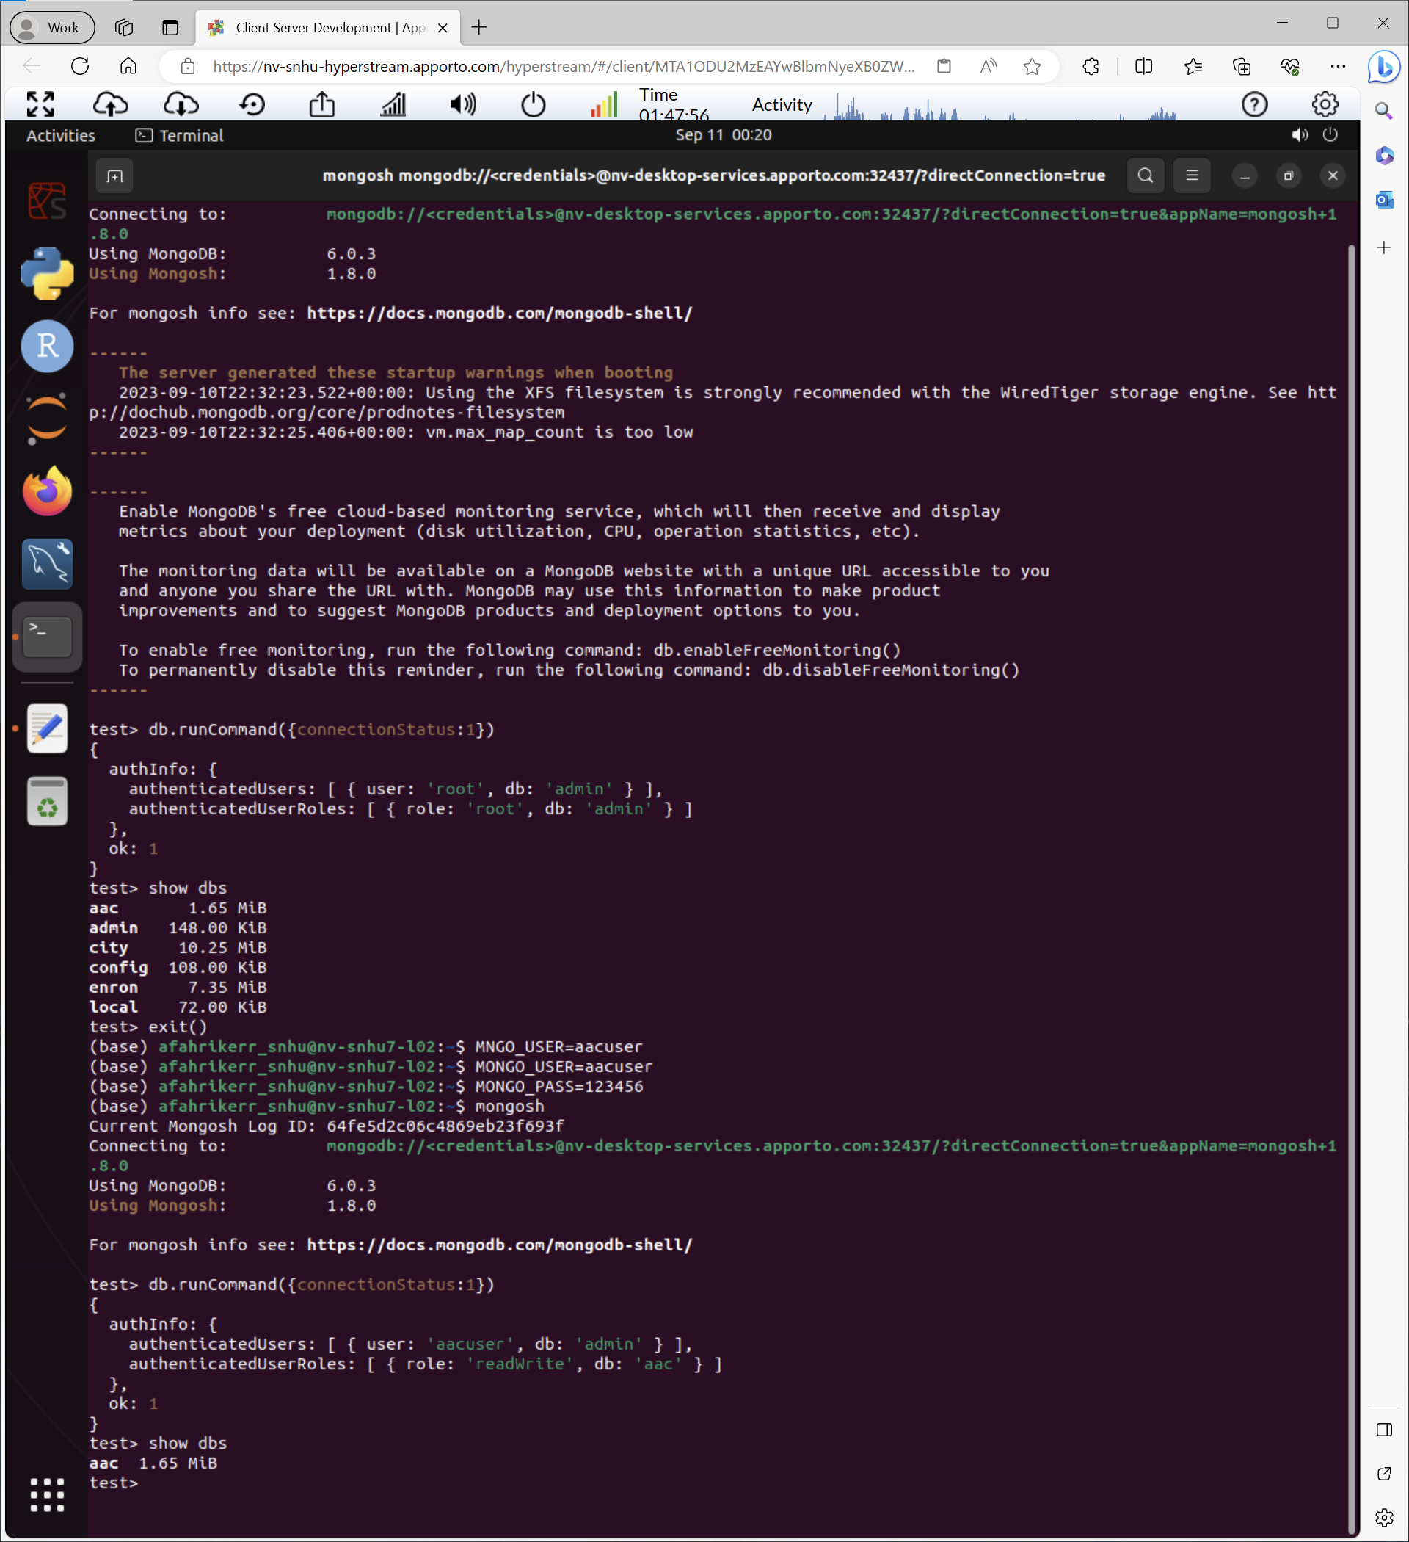

Now that we have our database and user set up, we used python to connect to our database and made some easy-to-use functions to interact with it (CRUD module). We used Jupyter Notebook to run the tests and show the results. We already explained how to use the functions above, so we won’t go over it again here.



**Part 2**

**Functionality, Tools, and Steps**- The client, Grazioso Salvare, requested that I create a dashboard to make interaction with the database easier. I decided to use DASH to build our dashboard. Dash provides several tools to make building an interactive webpage easy such as [Dash Leaflet (dash-leaflet-docs.onrender.com)](https://dash-leaflet-docs.onrender.com/) for the map and [Dash DataTable | Dash for Python Documentation | Plotly](https://dash.plotly.com/datatable) to display our data. I also used [plotly.express](https://plotly.com/python/pie-charts/) to make the pie chart for our page. You can see the imports used below.

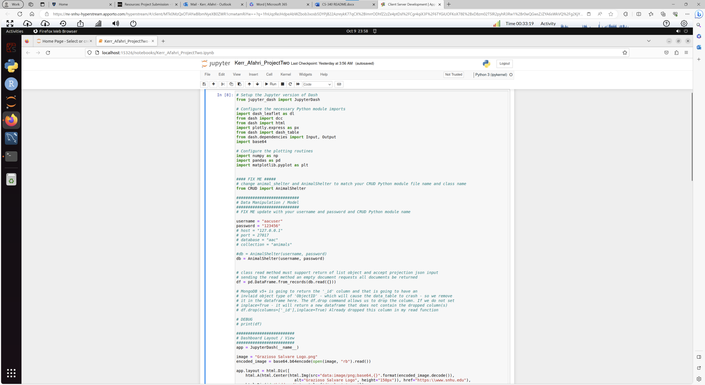

I first connected to and imported our database using our CRUD module from earlier. Then I designed the layout of the page using [Dash HTML Components | Dash for Python Documentation | Plotly](https://dash.plotly.com/dash-html-components). The client wanted their logo on the page so I placed it at the top and clicking on it will take you to their website. They also wanted to credit me as the creator of the page so I placed a header containing my name over the data table. I then placed the radio buttons for each rescue category and displayed the data table and graphs below that. You can see the layout code below.

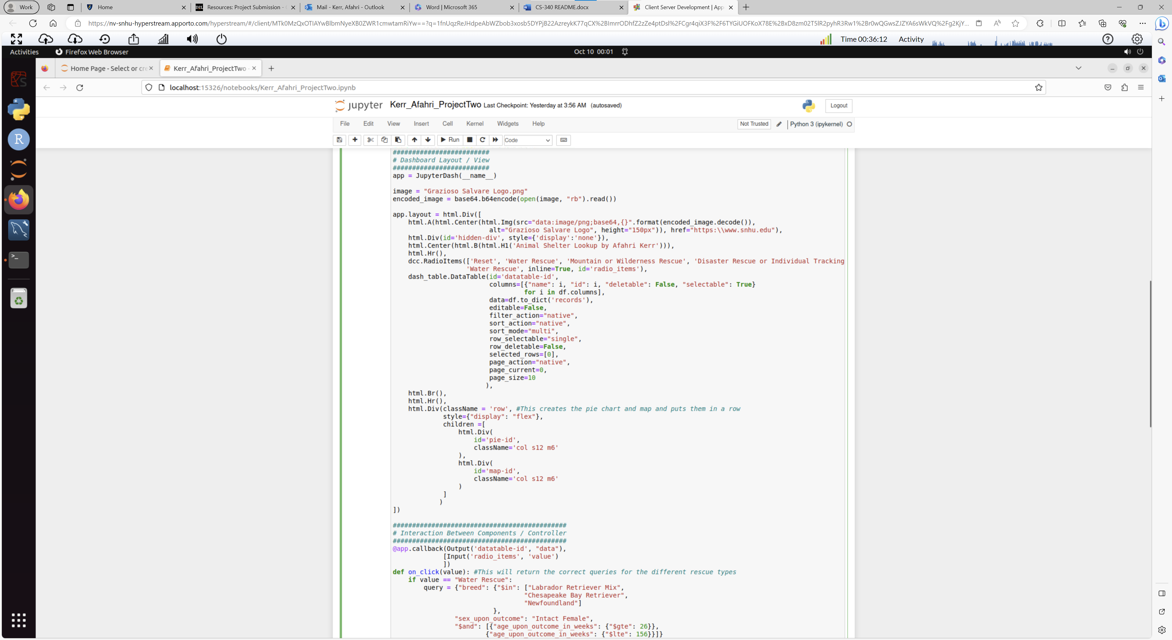

To get the graphs to update correctly I had to utilize Dash’s callback features and the read features of the CRUD module to gather the correct data and update the graphs. The client had specific animals in mind for each rescue type. You can see the queries below.

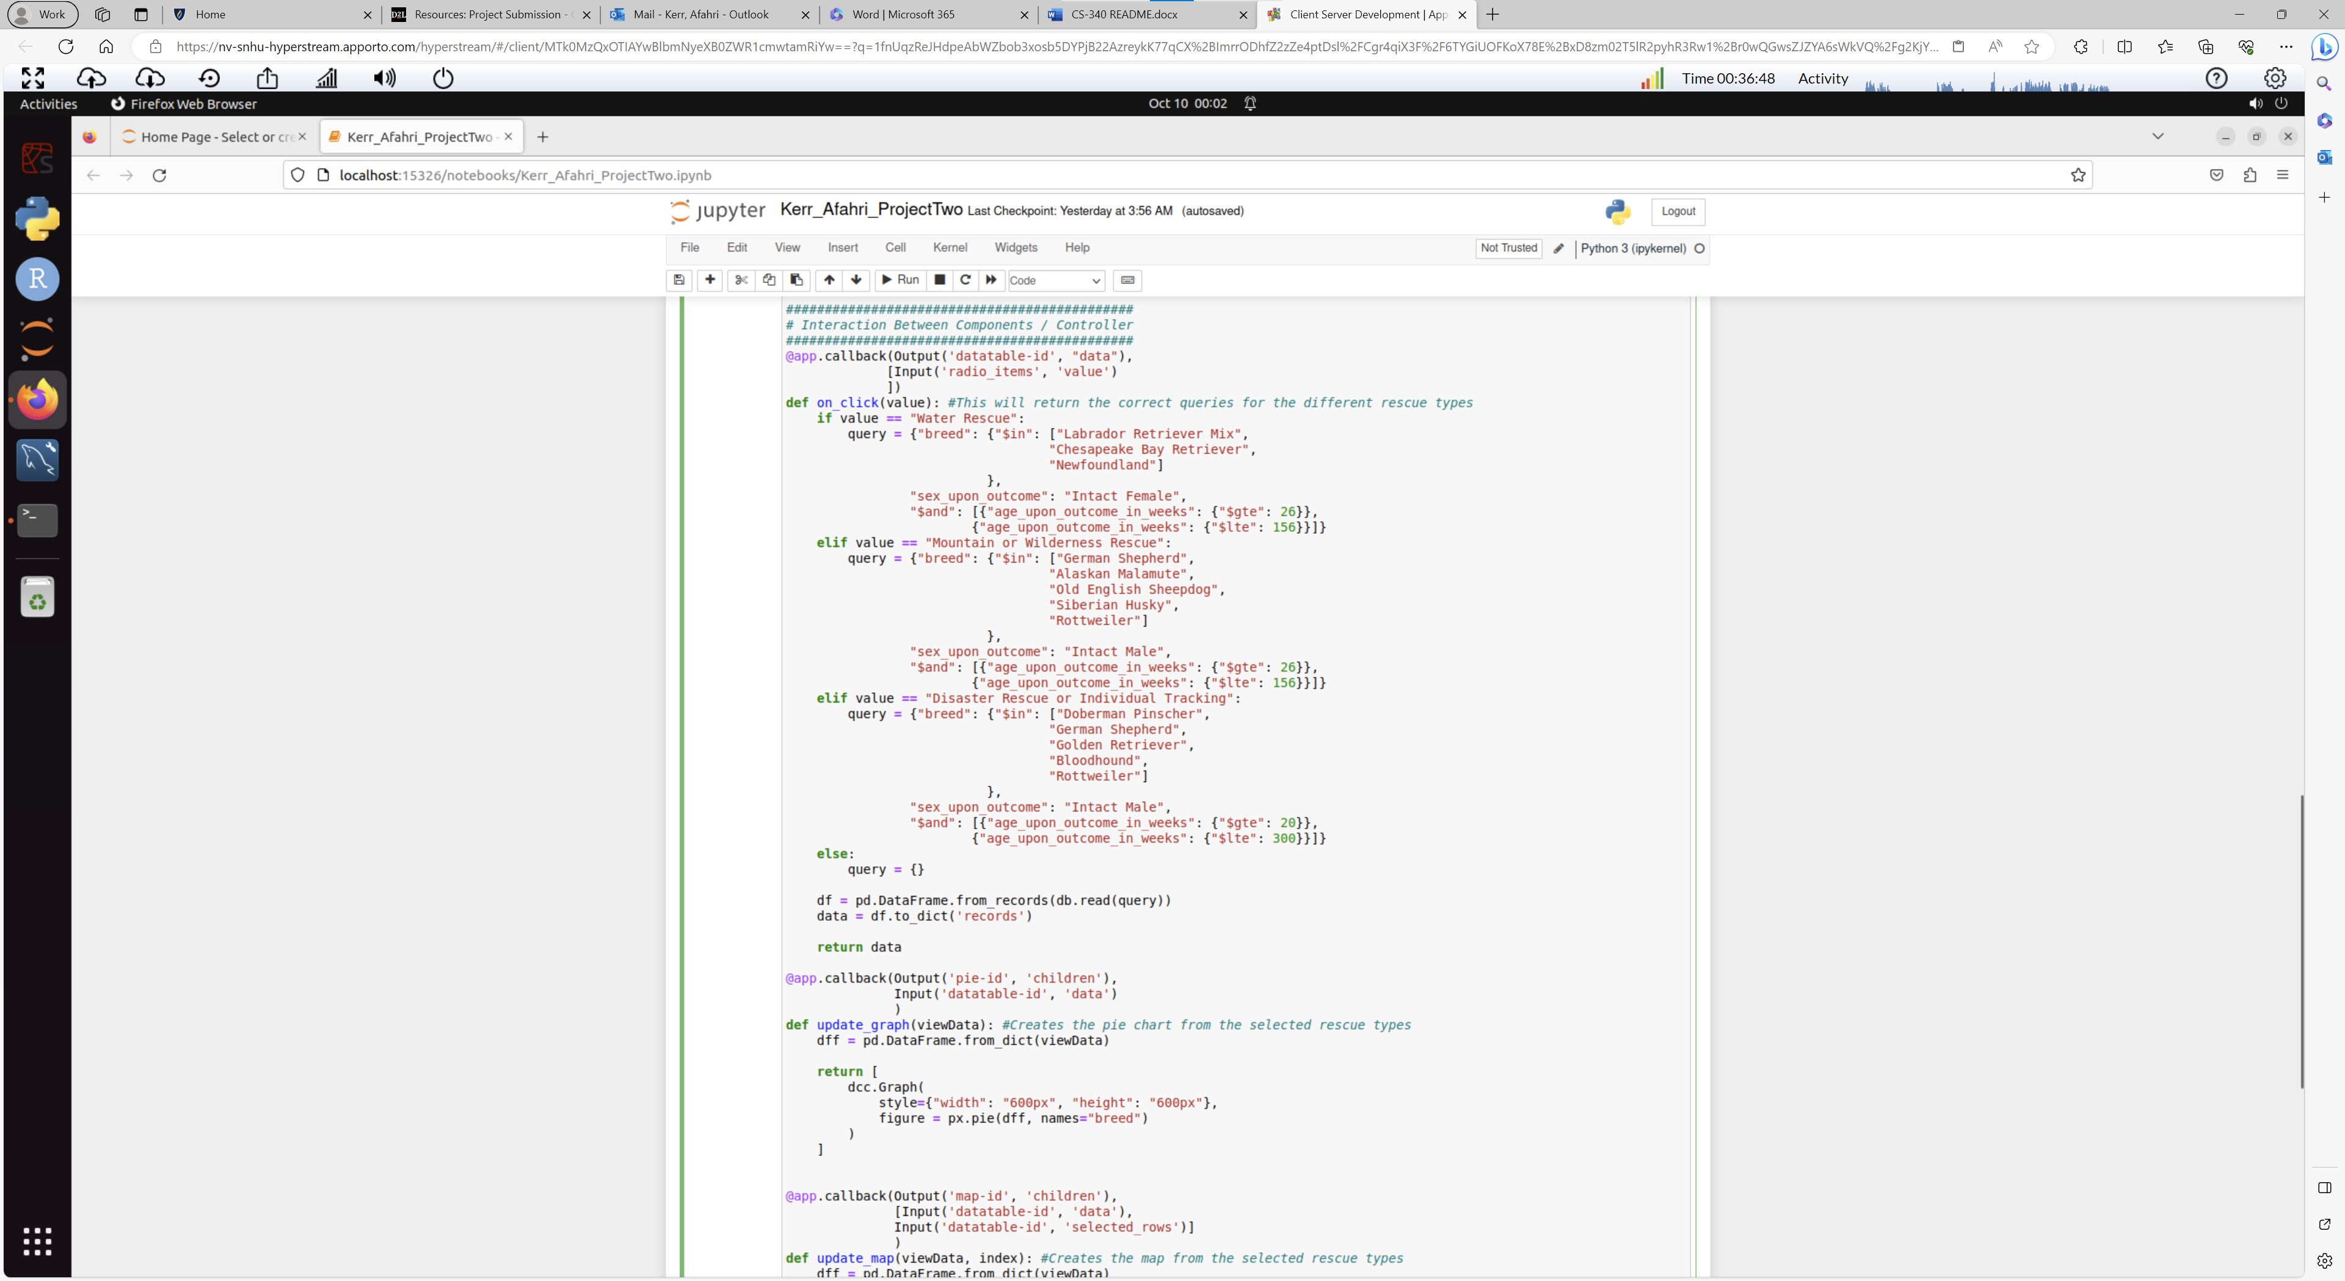

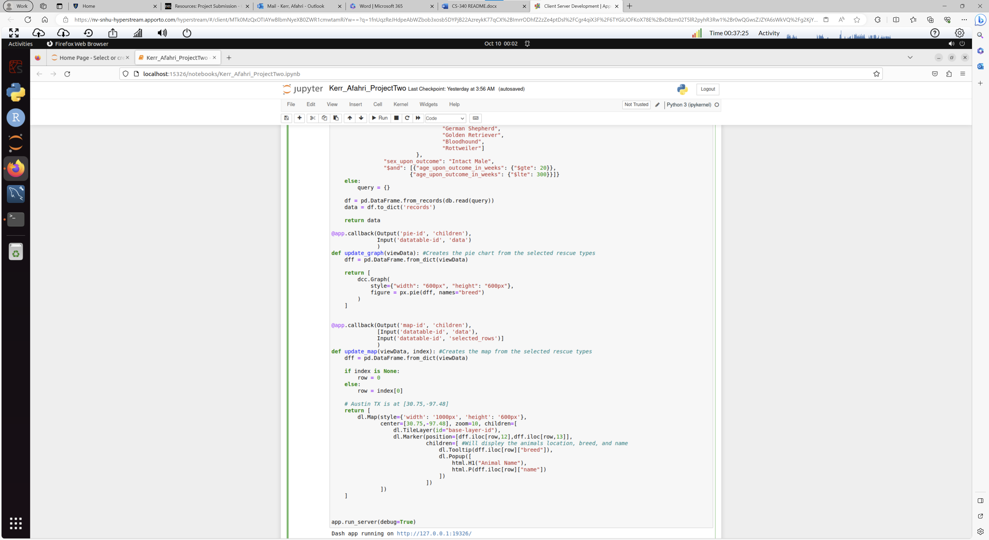

Now that you have seen the code I will show you what it all looks like. Here are the different rescue types in order Water Rescue, Mountain or Wilderness Rescue, Disaster Rescue or Individual Tracking, and then finally reset the data to the original table. Notice how the graphs update in each image. You can also select an animal to see its location updated on the map along with its breed and name if you click the pointer.

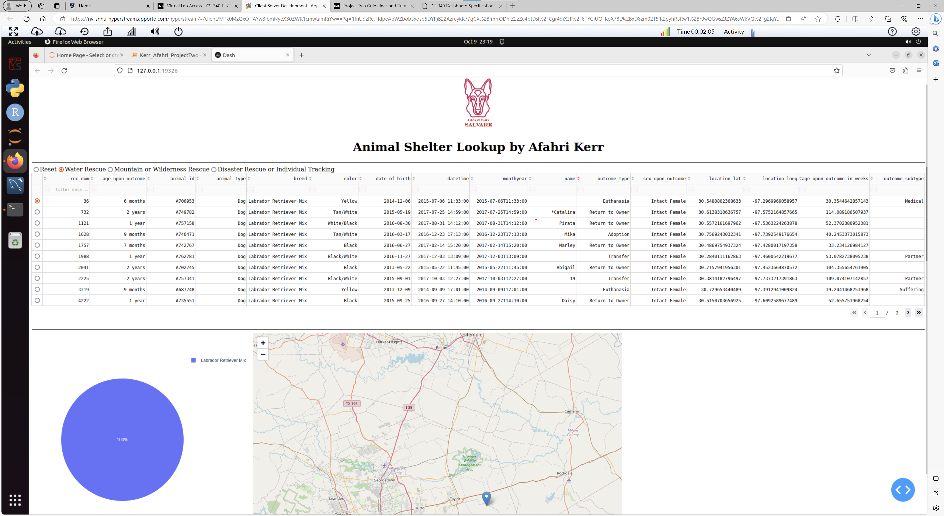

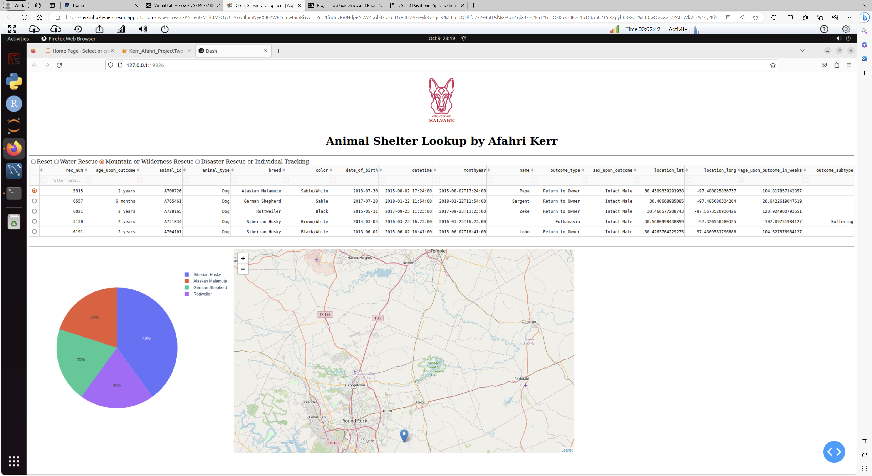

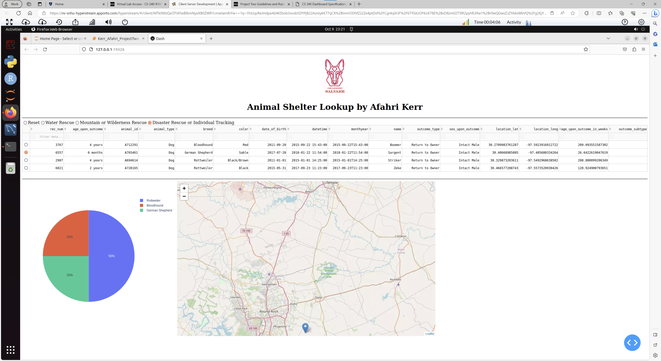

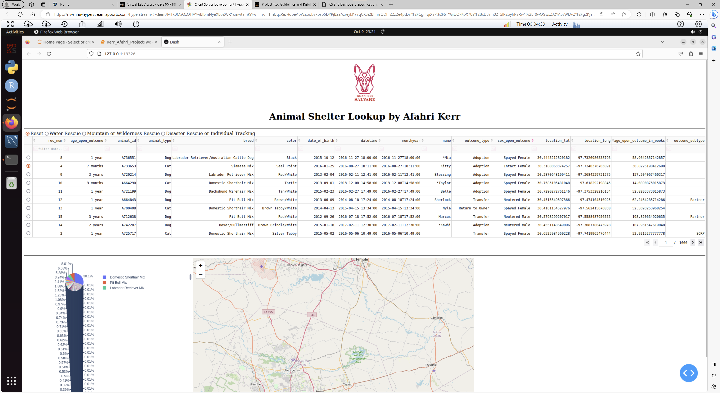

**Challenges-** The main challenge that I had for this project was learning how to use DASH since I had not used it before. I struggled at first with the correct callbacks but DASH provides very thorough documentation that is easy to follow. I also had an error updating my maps on startup but this was easily corrected by initially selecting a row. Good luck recreating or creating your own dashboard!